|  |
| --- |
| Hames Sutlard  99 Highwells Road  Hockleigh  01268 696969  [sexybois@pornhub.com](mailto:sexybois@pornhub.com) |

# **The FOod and drink agreement 2019**

## **The Drink Act 2019**

This legally binding document hereby decrees that James Anthony Pollard and Harold Reginald Sutton shall forever be in agreement that all drinks are owned and consumed equally amongst all parties involved. This applies to any drink bought or given to James Anthony Pollard or Harold Reginald Sutton. If all parties do not adhere to these set terms and breach contract they will be subject to a punishment decided by the elected punishment board.

Signed By James Anthony Pollard Signed By Harold Reginald Sutton

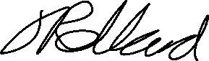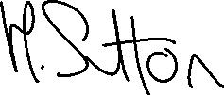

|  |
| --- |
| Hames Sutlard  99 Highwells Road  Hockleigh  01268 696969  [sexybois@pornhub.com](mailto:sexybois@pornhub.com) |

# **The FOod and drink agreement 2019**

## **The Pizza Act 2019**

This legally binding document hereby decrees that James Anthony Pollard and Harold Reginald Sutton shall forever be in agreement that every mouth, on an alternating rota, one shall purchase a large dominos pizza for both parties to consume equally. If all parties do not adhere to these set terms and breach contract they will be subject to a punishment decided by the elected punishment board.

Signed By James Anthony Pollard Signed By Harold Reginald Sutton

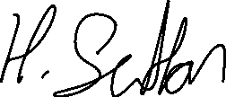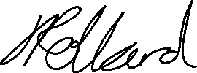

|  |
| --- |
| Hames Sutlard  99 Highwells Road  Hockleigh  01268 696969  [sexybois@pornhub.com](mailto:sexybois@pornhub.com) |

# **The FOod and drink agreement 2019**

## **The Moderation Board**

This declaration hereby states that upon breach of contract, by parties involved in the Food and Drink Agreement 2019, that Maisie Laura Sayers and Isabelle Jane Pringle Paley will decide the worthy punishment. The decision must be made without bias and with approval from the whole board before the punishment is agreed upon.

Members of the board are as stated below:

* CO-Chairwomen – Maisie Laura Sayers
* CO-Chairwoman – Isabelle Jane Pringle Paley

Signed By Isabelle Jane Pringle Paley Signed By Maisie Laura Sayers

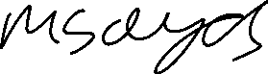

Acknowledgement and agreement of board members:



Signed By James Anthony Pollard Signed By Harold Reginald Sutton

